+-

***Print for Custom designed home***

* **Quick Print Details**
* Home is 24’x24’ Square with full basement.
* Cement block basement 12 block high
* 16’x24’ upstairs loft
* 16’ Shed Roof Dormer
* Metal Roofing
* Footings and cement layout shown
* All structure and beam layout shown
* MATERIALS COST ESTIMATE – last page

***Window Sizes (R.O.)***

1. Main Floor
   1. Two 60” x 48”
   2. One 48” x 48”
   3. Three 36” x 24”
2. Basement
   1. Two 36” x 24”
   2. Three 32.25” x 14.25”
3. Upstairs
   1. Two 48” x 48”
   2. Two 48” x 60”
4. **Total Windows**: 15 Windows

***Page Index***

1. House Exterior Southeast Corner
2. House Exterior Northeast Corner
3. House Exterior Southwest Corner
4. House Exterior Northwest Corner
5. House Exterior South Side Rafter Layout
6. House Exterior North Side Rafter Layout
7. House Exterior Top View Rafter Layout
8. House Interior Top View Joist Layout
9. House Interior South Side Joist Layout (Main Floor)
10. Upstairs Loft floor Joist Layout
11. Upstairs Loft Beam and Support Poles Layout
12. Basement Floor Plan
13. Main Floor Plan
14. Main Floor Plan Dimensions
15. Upstairs Floor Plan
16. Footing and Basement layout.
17. Sideview Rafter and Wall Joint Detail
18. North Side Exterior Wall Framing
19. East Side Exterior Wall Framing
20. South Side Exterior Wall Framing
21. West Side Exterior Wall Framing
22. Roof and Wall Exterior Insulation Details
23. Roof Peak Venting
24. East Side Deck Framing and Layout
25. West Side Deck Framing, Layout, and Footings
26. Site Plan (3D view of House, Drain Field, Septic, Well)
27. Site Plan Elevation Change
28. Satellite View of Property and Site Location
29. Materials Estimate

Design For:

Compass in Top Right Corner does not apply to 3D models with direction faces labeled

**House Exterior Southeast Corner**

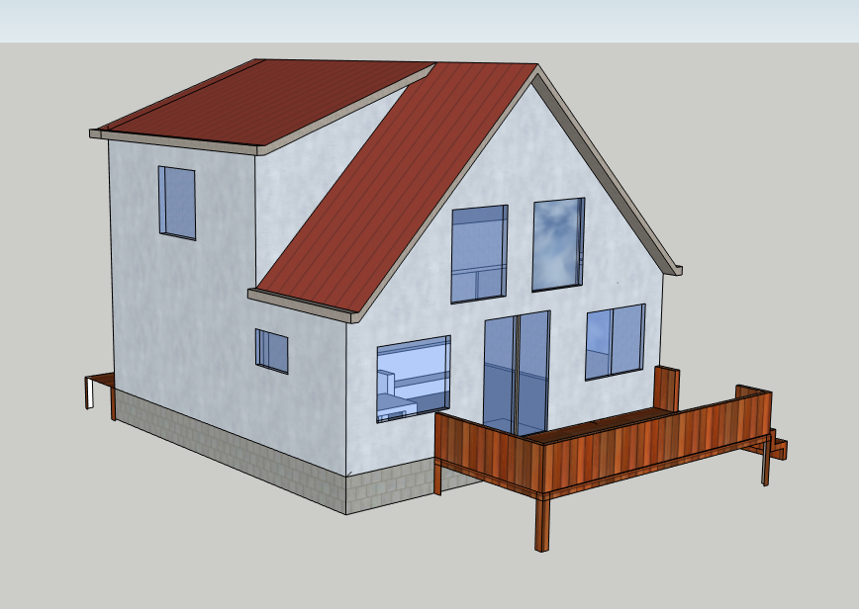

Basement Windows not pictured here in these details. Refer to Basement floor plan. Page 13

For Exterior Elevation Change along basement refer to page 28

**House Dimensions**.

* 24’ L x 24’ W x 28’8”H
* (Height Includes Basement)
* Basement Height: 12 Blocks (8’)
* Main Floor to Peak in Loft area: 20’8”
* Look at page 6 for rafter and roof dimensions

20’8”

16’

24’

6’6”

16’8”

**NOTE**: Refer to Page 6 for roof Pitch and additional rafter Layout lengths

**Window Dimensions** for all three floors are listed on Page 1 and Shown on respective Floor Plans not in 3D models

**NOTE**: Deck footings, layout, and info not shown on this Drawing. Refer to:

Deck Footings and layout:

Page: 25 and 26

24’ Width of house

8’

98’

16 Foot Shed Roof Dormer

**House Exterior Northeast Corner**

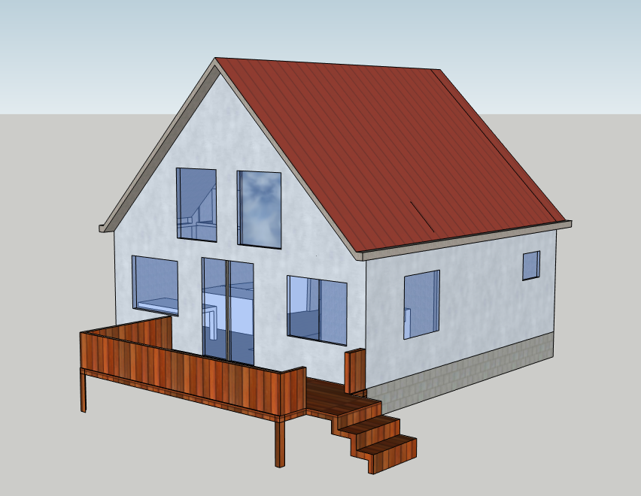

**Roofing Info:**

Material: Tin

Square ft of Tin: 815 ft

10’ x 3’ sheets

30 Sheets total

35$/Sheet

$1050 in sheets

Roof and Rafter Layout:

Page: 6

Note: Basement windows Not shown in 3D drawing. Refer to Basement Floor plan on page 13

**House Exterior Southwest Corner**

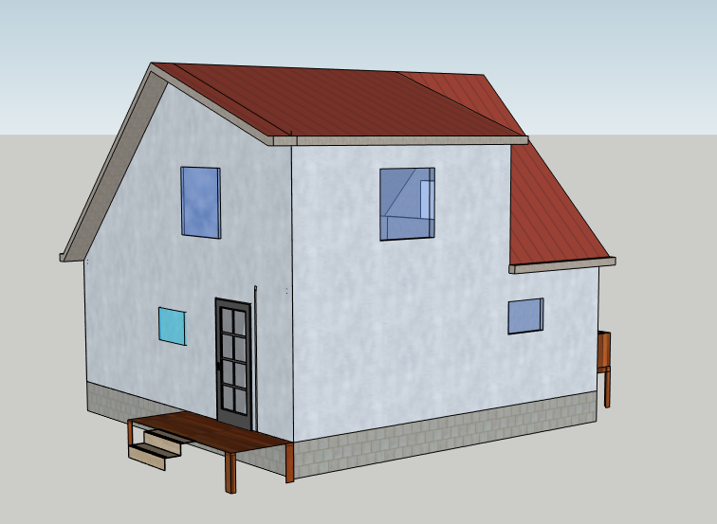

**NOTE**: Deck footings, layout, and info not shown on Drawing. Refer to:

Deck Footings and layout:

Page: 25 and 26

Other dimensions and Layouts shown on respective pages

12” of Eve Overhang

**House Exterior Northwest Corner**

**NOTE**: Deck footings, layout, and info not shown on Drawings. Refer to Deck Footings and layout:

Page: 25 and 26

Other dimensions and Layouts shown on respective floor plans and other page layouts

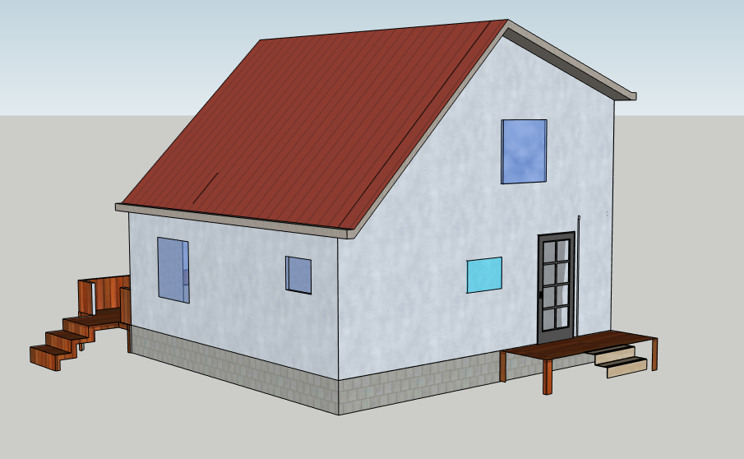

**House Exterior South Side Rafter layout**

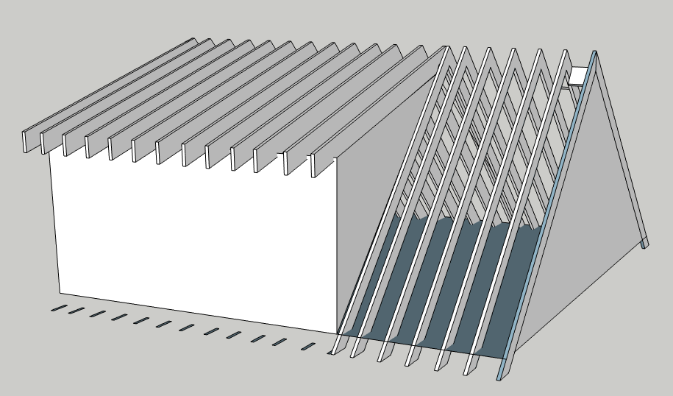

**Additional Rafter Info**

* Rafters: 2” x 12” lumber
* 12/12 Rafter Length: 18’
* 4/12 Rafter Length: 13.65’
* Spacing: 16”
* Thirteen 4/12 x 12/12 rafters
* Seven 12/12 Rafters
* Total # of Rafters: 20
* Rafters rest on Upstairs floor
* 12” of overhang

24’

96”

16’

Note: Eve Not Shown here

24’

Standard House Pitch

Dormer Roof Pitch

12

12

4

12

**House Exterior North Side Rafter layout**

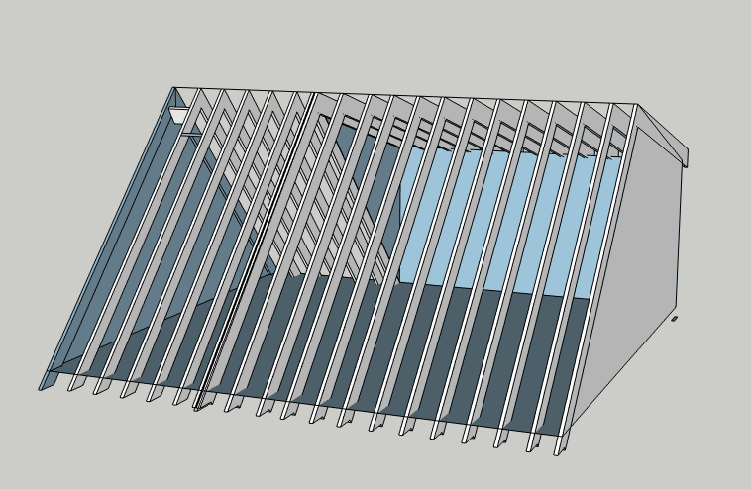

Roof Pitch

12

12

8’

24’

13.65’

18’

24’

**House Exterior Top View Rafter layout**

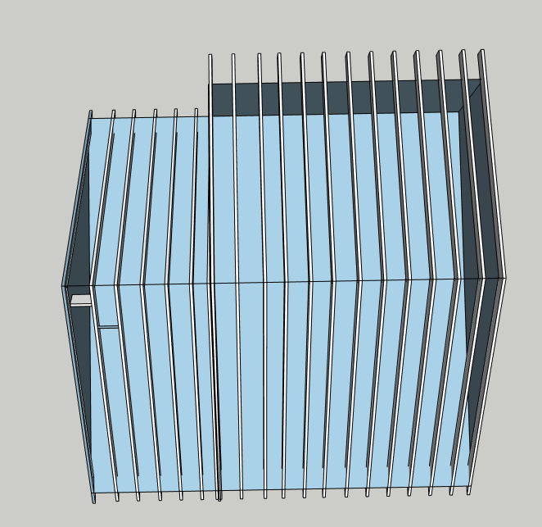

**House Interior Top View Joist layout (Main Floor)**

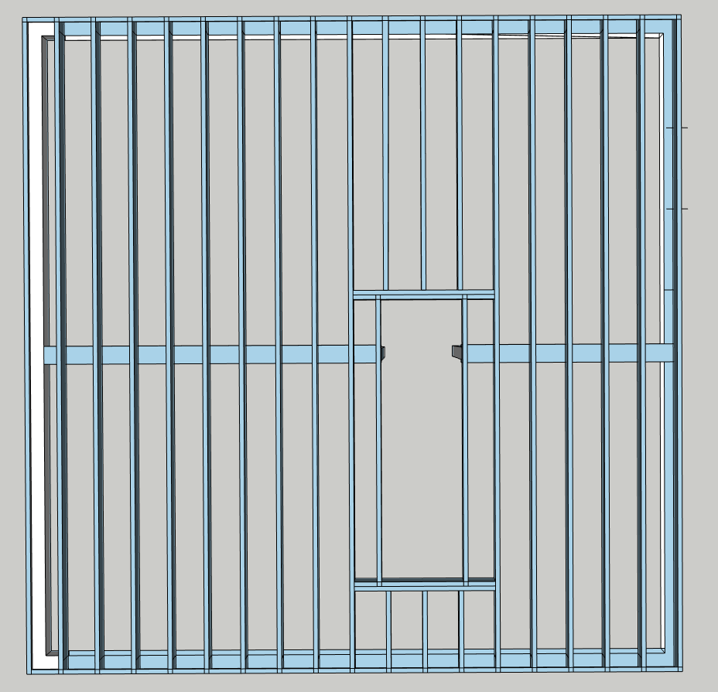

8’

3’

10’

**NOTE**: Refer to page 15 for more Size and Dimensions.

Sitting on top of Top Plate of Cement Block Wall.

**Main Floor Joist Details**

* Total Span: 24’ x 24’
* Joist size: 2” x 8”
* Joist Spacing: 16”
* Number of Joists: 19
* Hole for Stacked Stairways:

3’ x 11’

* 8”x 8” beam running down center (Center of 24’ span)
* Beams have 6” poles going down to footing in basement.
* Two headers in Stairwell:

64” long

* More details shown on next page

24’

24’

**House Interior South Side Joist layout (Main Floor)**

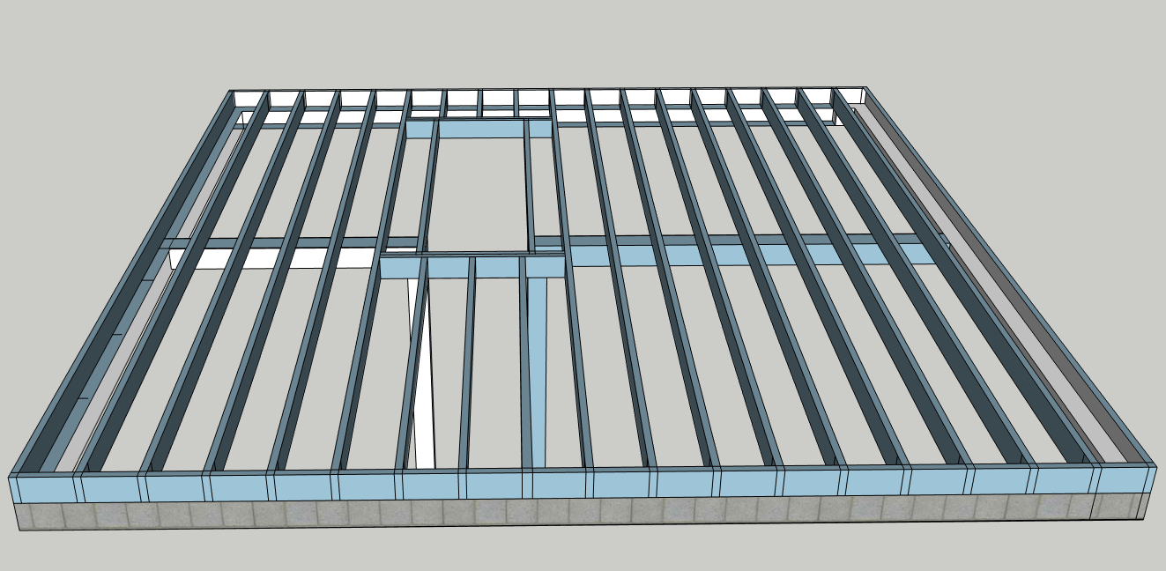

Stairway Headers

2” x 8” Floor Joists

8” x 8” Beam with support pole going to footing in basement

Basement Cement Block wall

Steel 4” Support Poles in Basement

End Cap 24’ span of 2” x 8”

**Upstairs LOFT Floor Joist Layout**

LVL Beam underneath edge of loft. Spans 24’ and carries only 8 feet.

LVL Beam: 3.5” x 9.25”

**Edge of Upstairs loft Looking into lower floor**

* 3’ high railing
* Beam support underneath
  + LVL beam span 24’
* 8” x 8” Support pole going to lower
* More detailed drawing of LVL Beam on next page

Interior stairway wall

Additional Upstairs floor info

* Floor resting on exterior 2” x 6” exterior/interior wood walls and 1 LVL beam and one 4” x 6” beam
* Stairways information and Tread/Riser info on pages 13 and 14\
* Joist spacing: 16” OC
  + Additional joists added for Stairway header
* Stairway hole. 11’ x 3’

24’

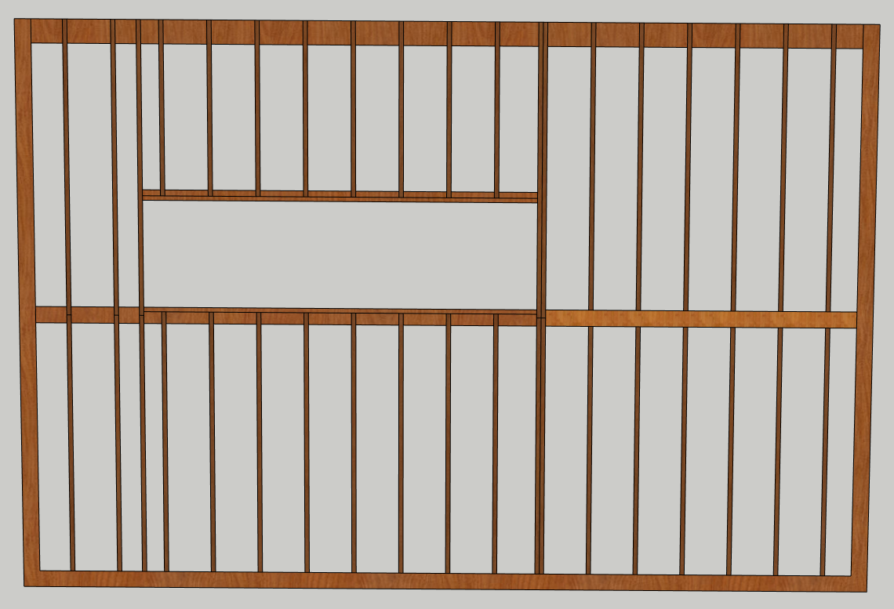

8’

Stairway going up to top in this direction. Stairs details on Stairs detail page 14

16’

Dormer Side

4” x 6” beam extended off from interior bathroom wall hidden in floor with joists Hangered into it.

Top of Downstairs walls

Upstairs Joists rest on these

2” x 8” Floor Joists

**Upstairs LOFT Beam and Support poles layout**

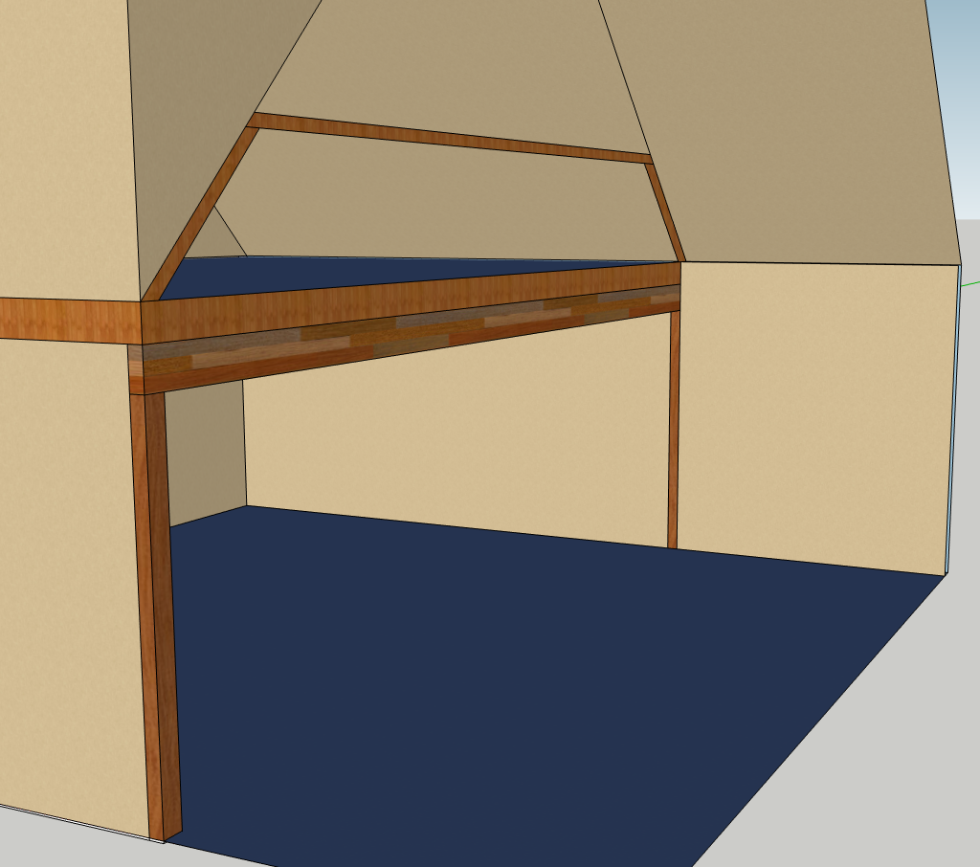

36” Loft railing

Looking onto main floor

**NOTE**: Railing spindles not shown spaced 4” O.C.

Upstairs Floor

2” x 8” Joists

3.5” x 9.25” LVL Beam that spans 24’ and carries 8’ from interior wall, to hold up edge of Upstairs loft floor.

**Note:** Just a visual of the loft and Beam Layout. Not all walls shown here. Some walls are cutout. Emphasis shows loft beam and support

4” x 6” beams hidden in wall going down to main floor to hold up LVL Beam

**Basement Floor Plan**

Electrical Box

Basement Window Rough Opening Key

1. 32.25” x 14.25”
2. 24” x 36”

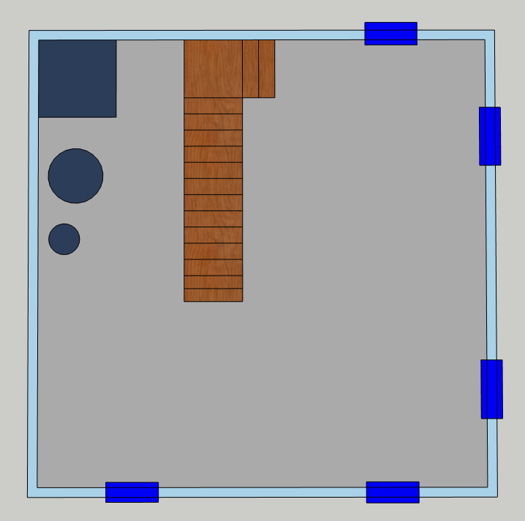

**Downstairs Stairwell Info:**

12 Blocks Between Upstairs floor and Basement Floor.

3’ x 3’ Landing

12 treads to main floor

Block Height: 8”

Block Wall Height: 96”

Risers: 14 at 7.5”

1 tread to landing

Treads: 13 at 12”

8’

Well Tank

Hot Water Heater

3” Cement Floor

Propane Furnace

3’ Landing

14’

4’

4’

4’

4’

4’

2.

2.

12 Block high Cement Block walls

1.

1.

1.

**Main Floor Plan**

Stacked Stairwell. The stairwell shown here goes upstairs, the downstairs stairs are shown on the Basement Floor Plan.

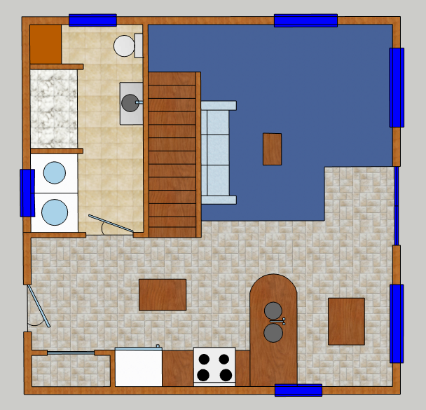

**Upstairs Stairwell Information:**

3-foot Landing on bottom, Goes up into loft.

Risers: 14 at 7.5”

Treads: 13 at 12”

All Main floor Wall, Window and Door Details shown on:

Main Floor Plan Dimensions (Walls, Doors, Windows)

Page: 15

Main Entrance door

36” x 80” Opening

All Door openings other than Glass Slider are this dimension

East Side Glass Slider Door R.O: 60” x 80”

Washer and Dryer

Dining

Bathroom

Living Room

Kitchen

Fridge

Pantry

SHOWER

**Main Floor Plan Dimensions (Walls, Doors, Windows)**

**Window and Door key**

1. Window R.O: 48”L x 48”H
2. Window R.O: 36”L x 24”H
3. Window R.O: 60”L x 48”H
4. Exterior Front Door R.O: 36”W x 80”H
5. Glass Slider Door R.O: 60”W x 80”H
6. Bathroom Door R.O: 36”W x 80”H
7. Archway: NO DOOR:R.O: 36”W x 80”H
8. Pantry Archway: NO DOOR

R.O. 36”W x 80”H

**Wall Details:**

* **Exterior Walls**:
* 2” x 6” studs
* Studs Spaced every 16”
* **Interior Walls**:
* 2” x 4” studs
* Studs Spaced every 16”
* Wall and Stud Details shown on another Page.

2’

2’6”

2’6”

2’

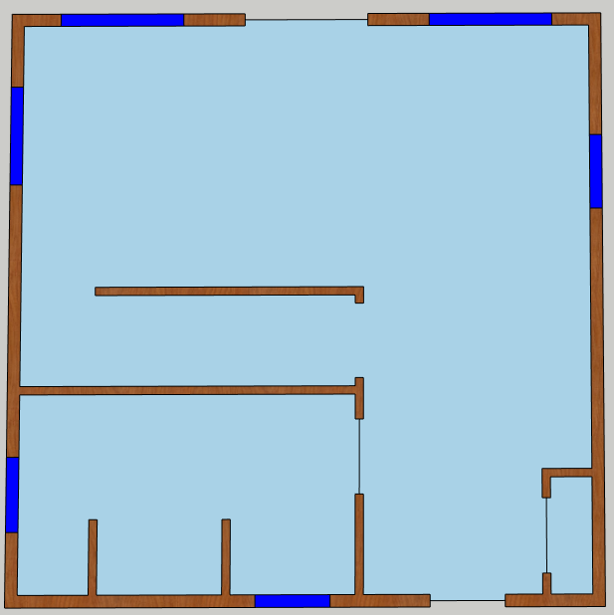

9’6”

6 1/2”

’

2’ 1/2”

’

1’6”

’

7’6”

16’3”

’

4’9”

3’

5’

2’6”

4’

11’

7

4’6”

”

3’

5’

3’

’

3’

’

3’

17’

’

2

4

8

5

3

1

3’6”

3’

14’

’

11’

6

3

2

2

**Upstairs Floor Plan**

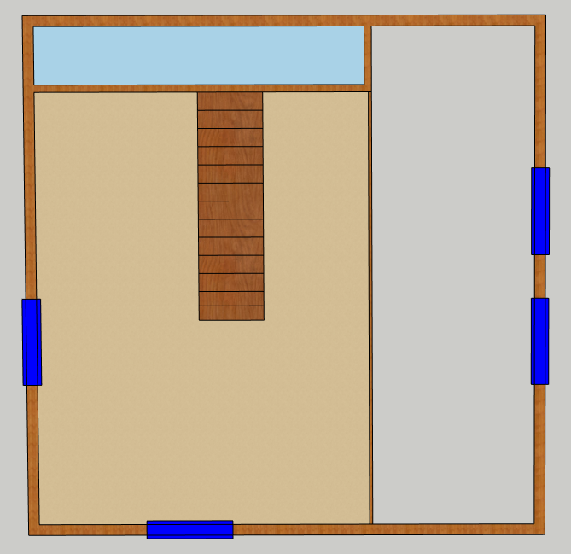

5

4

**Window and Door key**

1. Upstairs Window R.O: 48”H x 48” W
2. Upstairs Window R.O: 60”H x 48” W
3. No Doors in the Upstairs
4. 36” Railing around Staircase
5. 36” Railing on edge of Loft

7’7”

7’7”

Upstairs Loft, Open Space looking to main floor

7’

6’

6’

16’

Upstairs One Bedroom

20’

’

24’

3’

Stairwell Railing 36” high

2

2

1

1

Loft Railing

36” High

Knee Wall

**Footing and Basement layout**

2” x 8” Treated Sill Plate

2” x 8” Ledger Board

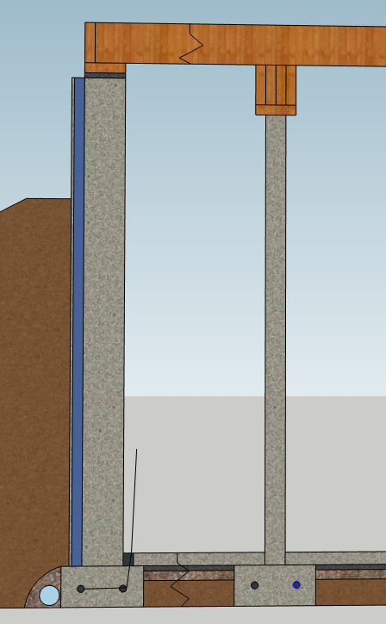

Expansion Joint

Outside Fill

Sill Plate Seal

Perforated Drain Tile

Gravel

Mortar Stucko

3” R15 Styrofoam Insulation

Ground Wire

Gravel

Vapor Barrier

3” Cement floor

4” Steel Basement Beam

24’ Span Beam

Four 2” x 8”s nailed/glued

2” x 8” x 12’ Floor Joists

12 Block high Cement Block wall

Not to Scale:

12’

Two ½” Re-Bar Continuous around footer

8” x 16” footings

**Sideview Rafter and Wall Joint Detail**

**Additional Information**

* More details about this joint setup, insultation and sheeting on page 23

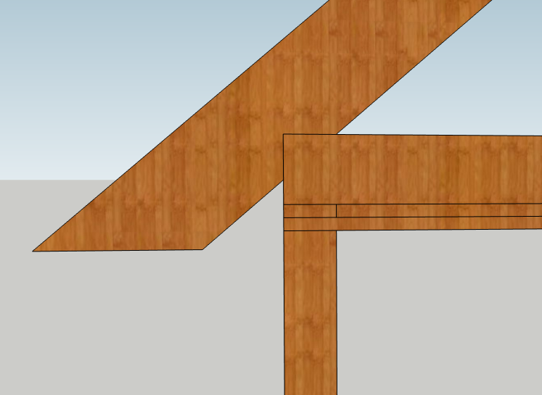

Top Plate

12” of Overhang

2” x 6” exterior wall

2” x 12” Rafter

Upstairs 2” x 8” Floor Joists

**North Side Exterior Wall Framing**

**Additional Info**

All Studs and boards are 2” x 6” on all Exterior Walls.

Stud Spacing is 16” pulling from the Left side to Start.

All Headers 2” x 8”

8’

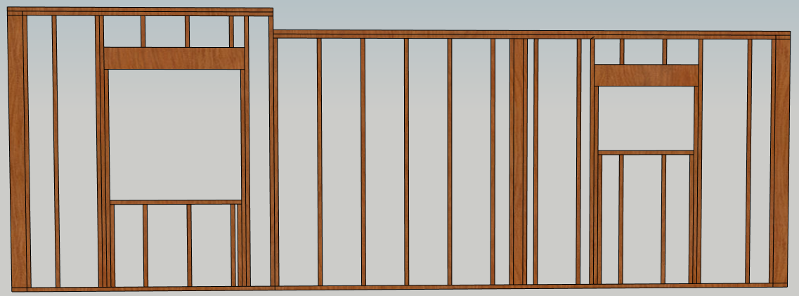

R.O: 24” x 36”

Header Height: 6’2”

R.O: 48” x 48”

Header Height: 80”

16”O.C.

8’

8’8””

8’6””

3’

Top Plate

8” Space Left for Upstairs 2” x 8” Loft Floor

17’

3’

Wall Buck for

2” x 4” Interior Wall

24’

**East Side Exterior Wall Framing**

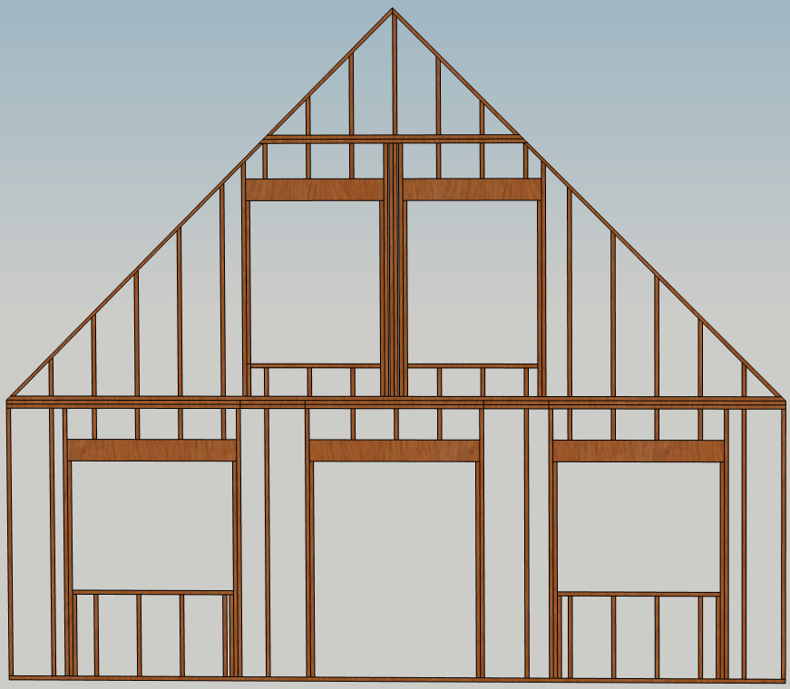

**Additional Information**

* Wall is 8” higher than 8’ to account for no floor due to loft
* 12/12 Pitch on the roof
* All Headers 2” x 8”
* To find Header length add 3” to R.O. Length

R.O: 60” x 48”

Header Height: 80”

R.O: 60” x 48”

Header Height: 80”

20’8”

1’

4’”

8’”

7’7”

7’7”

8’8”

24’

9’6”

9’6”

2’

2’

R.O: 60” x 80”

R.O: 48” x 60”

Header H: 6’

R.O: 48” x 60”

Header H: 6’

**South Side Exterior Wall Framing**

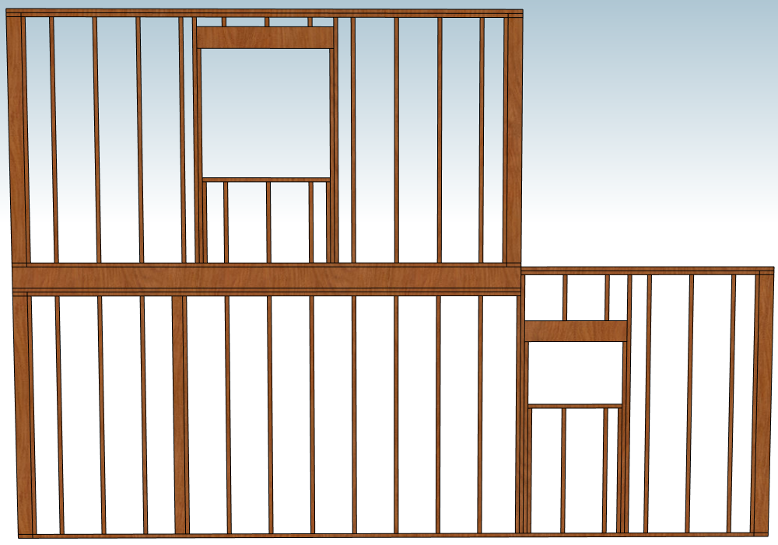

2” x 8” Floor Joists

R.O: 24” x 36”

Header H: 6’2”

Top Plate

16’8”

8’

8’8”

8’

4’9”

5’

6’

6’

R.O: 48” x 48”

Header H: 80”

**Additional Info**

* All Exterior Walls 2” x 6” lumber
* 16” O.C. Spacing between Studs Pulling from left
* 2” x 8” headers
* To find Header length add 3” to R.O. Length
* Right 8’ wall section 8” higher to match floor
* 2” x 4” wall bucks shown for interior walls

**West Side Exterior Wall Framing**

**Additional Info**

* Add 3” to R.O. length to find Header Length
* 8’ H wall sections with 8” floor in between them
* All Headers 2” x 8”
* 2” x 4” wall bucks shown for interior walls
* Studs Spaced every 16” pulling from the right outer edge
* Interior Walls with be framed with same methods just 2” x 4” lumber instead of 2” x 6”
* 4/12 vs 12/12 roof pitch change due to dormer extending all the way to this side of the house

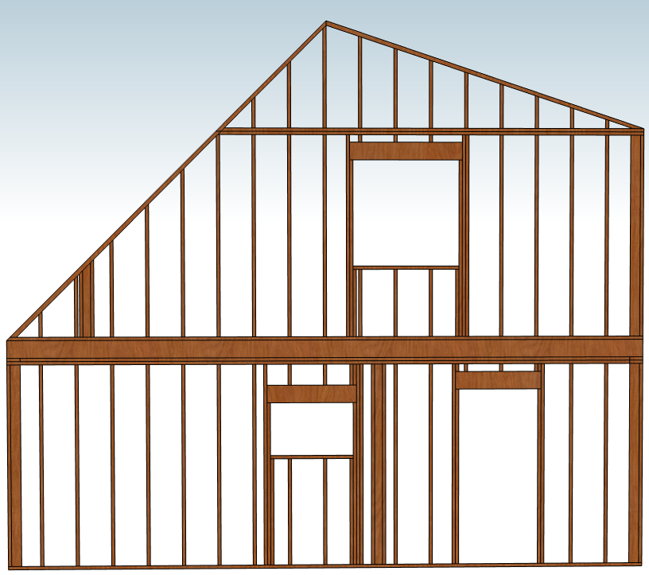

4’

16’8”

R.O: 48” x 48”

Header H: 80”

7’

3’

R.O: 36” x 80”

R.O: 24” x 36”

Header H: 6’2”

24’

10’

11’

4’

North side 2” x 6” Exterior Walls

South side 2” x 6” Exterior Walls

**Roof and Wall Exterior Insulation Details**

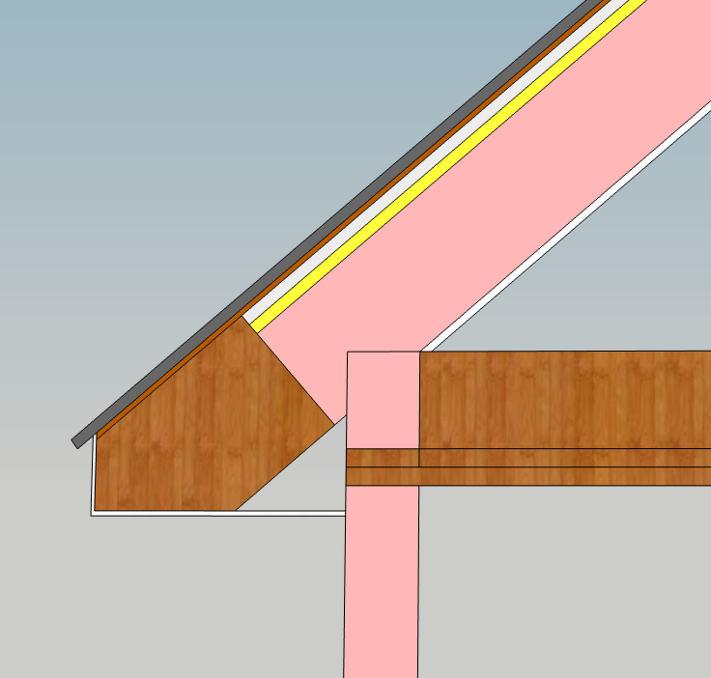

Tin Sheeting

5/8” thick Drywall Interior finish

8” R30 Fiberglass Roll Insulation filled in between Rafters

5 ½” R21 Fiberglass Roll Insulation

Vapor Barrier

Plywood Sheeting

1 1/2” Air Gap

2” Foam Insulation Board

Upstairs Floor

**Note:** All Interior finished with 5/8” Drywall

Vented Aluminum Soffit/fascia

**Roof Peak Venting**

Aluminum Roof Ridge Vent

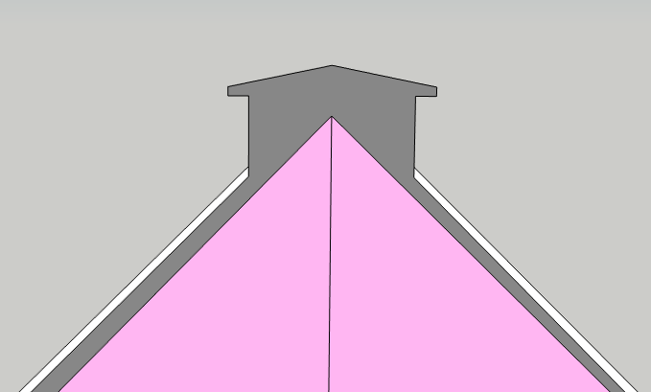

**Additional Information**

* More Details about insulation on previous page
* Ridge Vent not drawn to scale. Only here to show the vent linking the air gap and peak.

1 1/2” Air Gap

Fiberglass Insulation

More details on previous page

Tin Sheeting

**East Side Deck Framing and Layout**

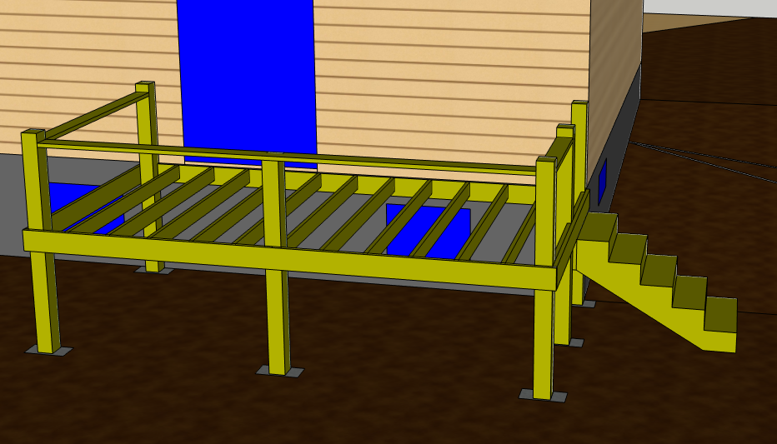

**East Side Deck Framing details.**

* All Lumber is treated lumber
* Dimensions: 16’L x 8’W
* 4’ between top of Deck and Dirt
* Six 11’ 6” x 6” beams going into the ground 42” deep with cement block house pier footing underneath
  + Detail on next page (page 26) of deck footing
* Twelve 2” x 6” Joists to hold up decking floor
* 3’ railing all the way around with a 3’ opening for the stairs
* Stairs information
  + Risers: 5 risers at 8” each
    - Span: 4’ up
  + Treads: 5 treads at 12” each
    - Span: 5’ out
* Deck floor treated 5/4-in x 6-in
  + Not shown
* Railing spindles not shown in drawing
  + Spindles spaced every 4”

7’

4’

16’

Poles all continues 42” underground

To cement block house pier footing

**West Side Deck Framing, Layout, and Footings (Block House Piers)**

**West Side Deck Layout and Details**

* All lumber is treated lumber
* Dimensions: 8’L x 6’W
* 2’ between top of Deck and Dirt
* Five 2” x 6” Joists to hold up deck floor
* 3’ railing all the way around with a 3’ opening for the stairs
* Stairs information
  + Risers: 3 at 6” each
    - Span: 2’ up
  + Treads: 3 at 12” each
    - Span: 3’ out
* Railing spindles not shown
  + Spindles spaced every 4”
* Deck floor treated 5/4-in x 6-in
  + Not shown

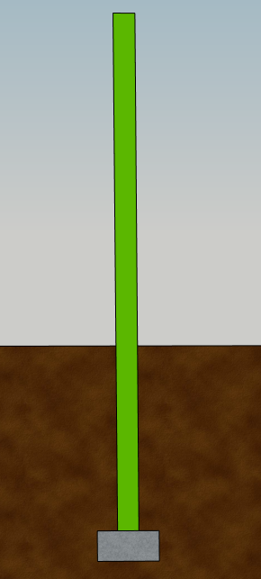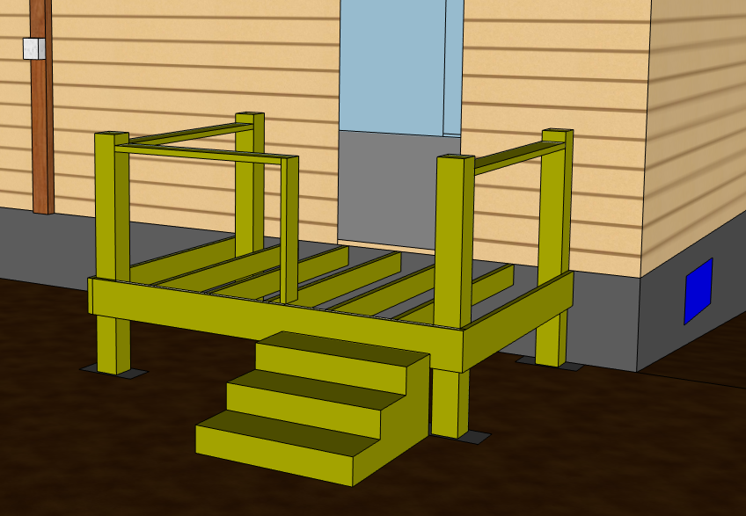

**Deck Footing Details**

* Each 6” x 6” pole has 42” buried underground resting on 8” Block house Pier footing
* East Deck
  + Six 6” x 6” poles and sticks up 7’ above the ground so they are 11’ in total
* West Deck
  + Four 6” x 6” poles and stick up 5’ above ground so they are 9’ in total

5’

8’

6’

**Site Plan (3D view of House, Drain Field, Septic, Well)**

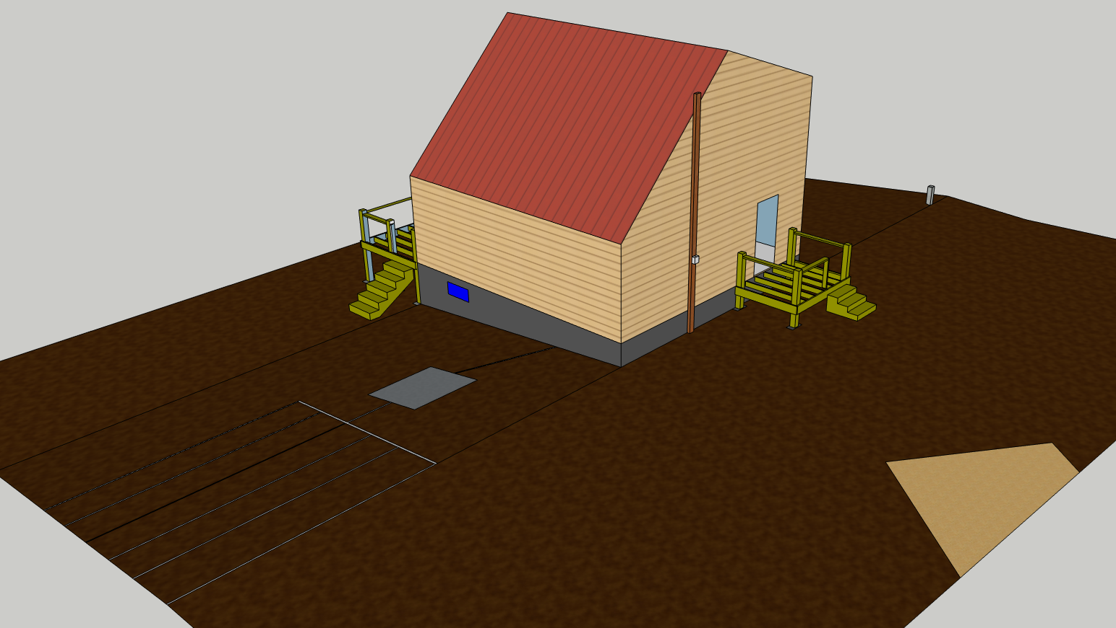

**Note:** Rough model of house, not all windows and details shown

Well (25ft from house and 57’ from septic)

Drain Field

Septic Tank

Electric

Plumbing pipe exiting house

Driveway

**Site Plan Elevation Change**

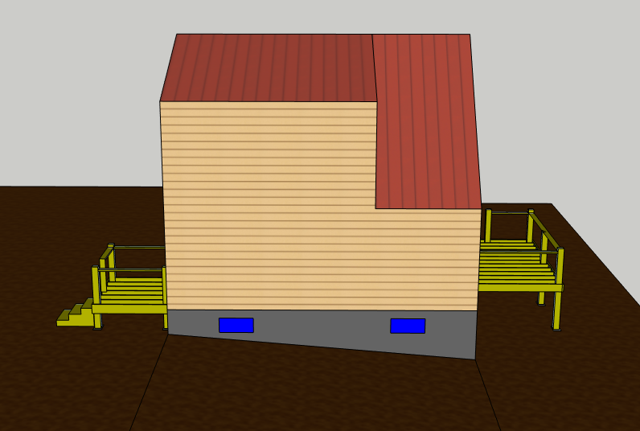

**Note:** Rough model of house, not all windows shown

**2’**

**4’**